Name:- Harpal Singh

Assignment:- 8

**Final Product/Outcome - a description of what you produced**

This project is undertaken for the hostel complaint system. Where students can complaints for the hostel room Maintenance. Students can use open interface based on web for firing the complaint into the system. This process includes two modules.

1. Users.
2. Admin.

Users: it is the students who can using web interface fire the complaint. These complaint can be regarding any civil work for the hostel.

Admin: it is the administrator who will be allocating the complaints to the respective department. And also note down the time and date under which complaint will be addressed. It is the interface where admin can keep vigil over to the system for the suggestions and also regarding the remarks that the client will give for the system.

1. Home Page:

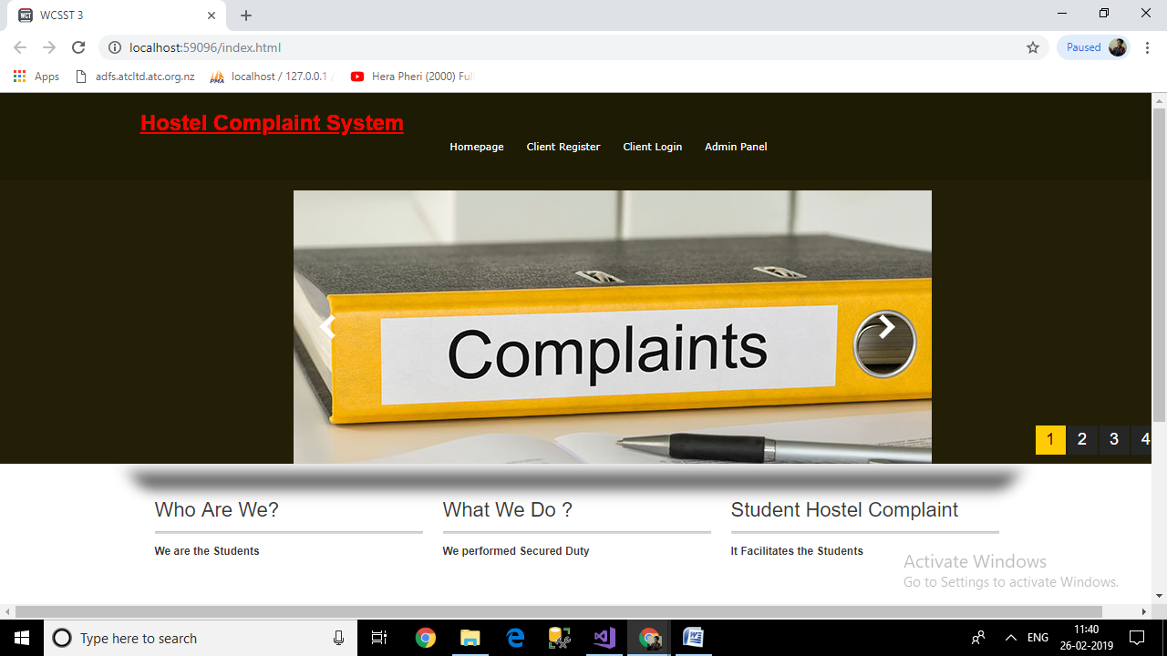

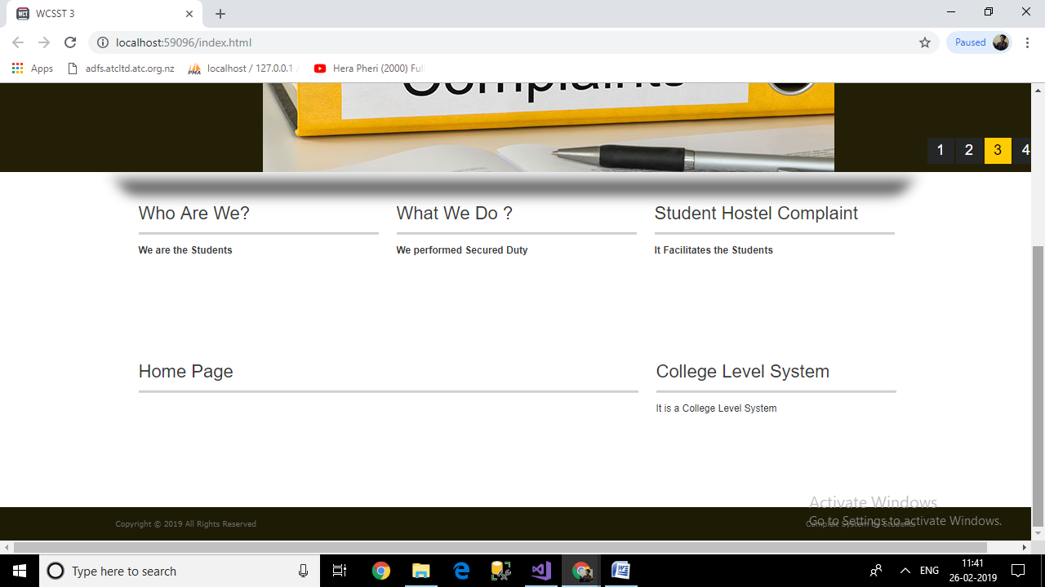

it includes top level navigation bar. Where client can click on to the new complaint. Where he can give the respective details of the work he need to perform from the administrator.

1. Client new Complaint interface.

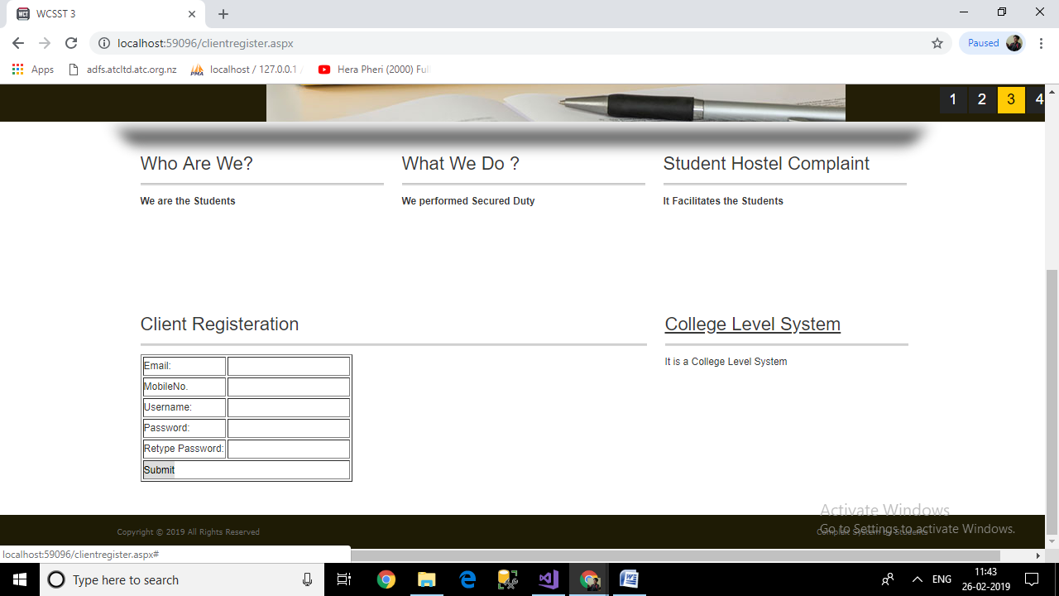

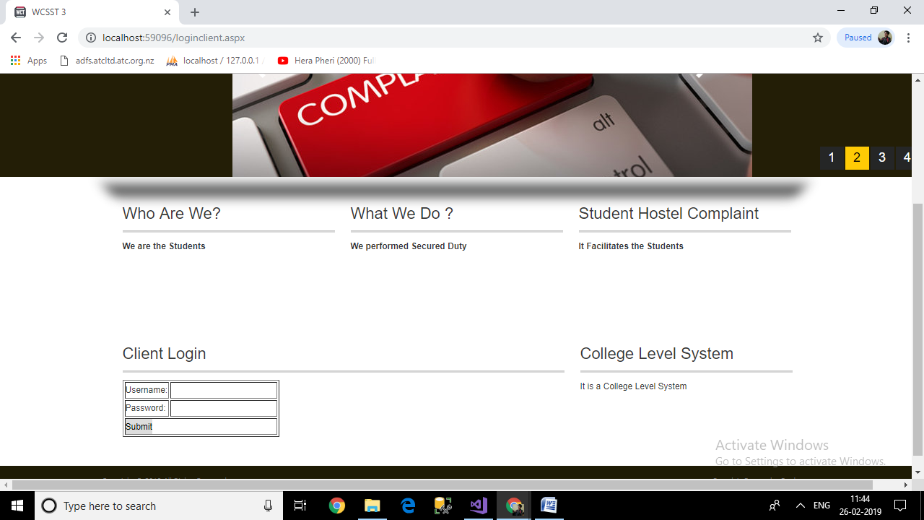

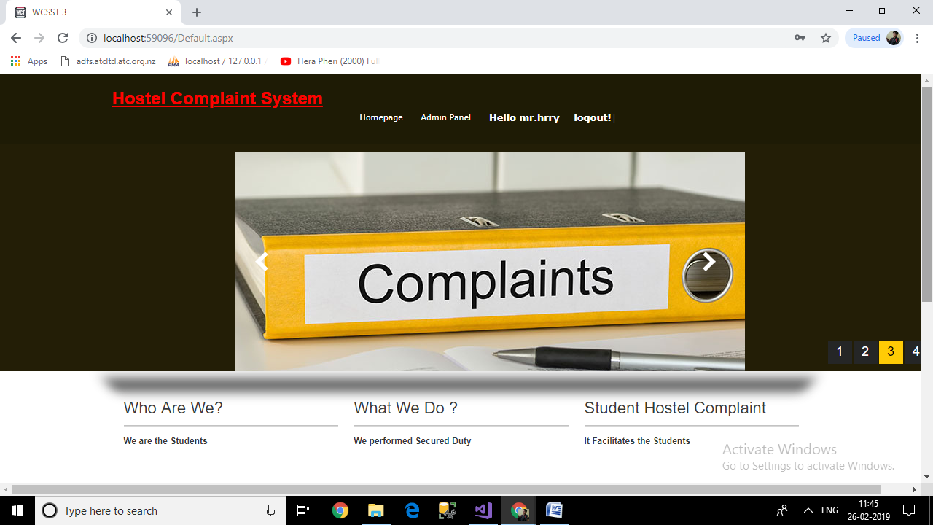

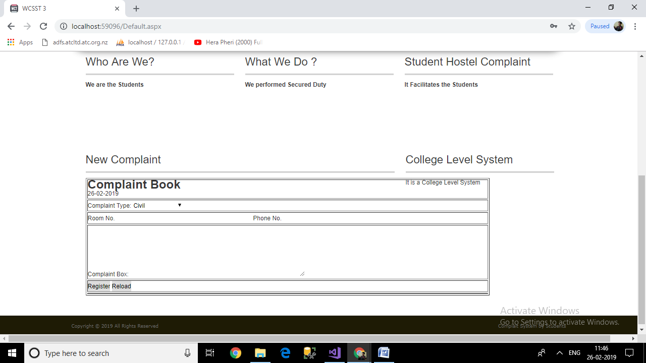

It includes various form fields where client can send the details of the complaint.

1. Admin Login

Any person cannot enter into the admin module. Only legal person will be allowed to enter into the admin module. For it correct username and password will be required.

1. Admin Panel

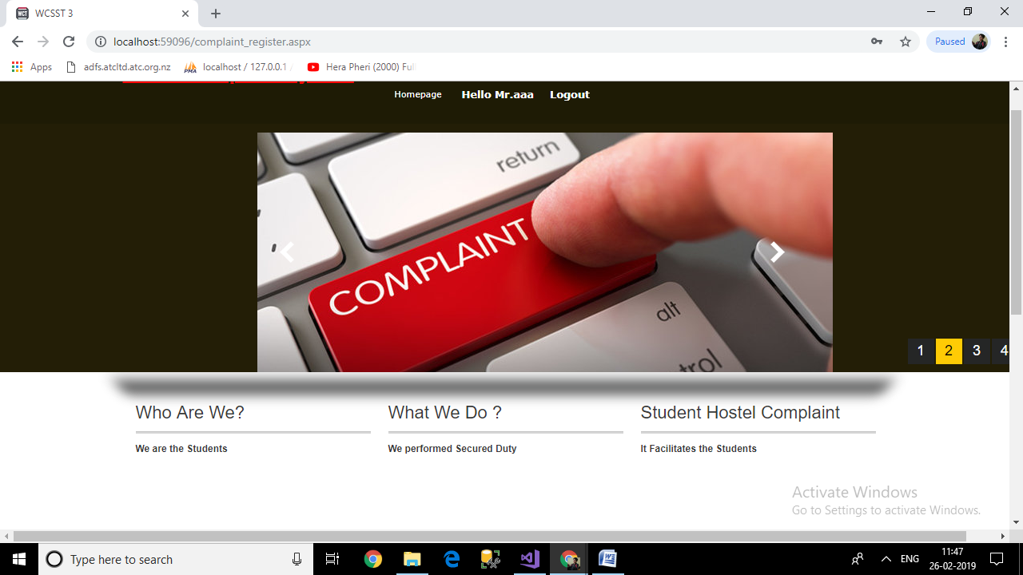

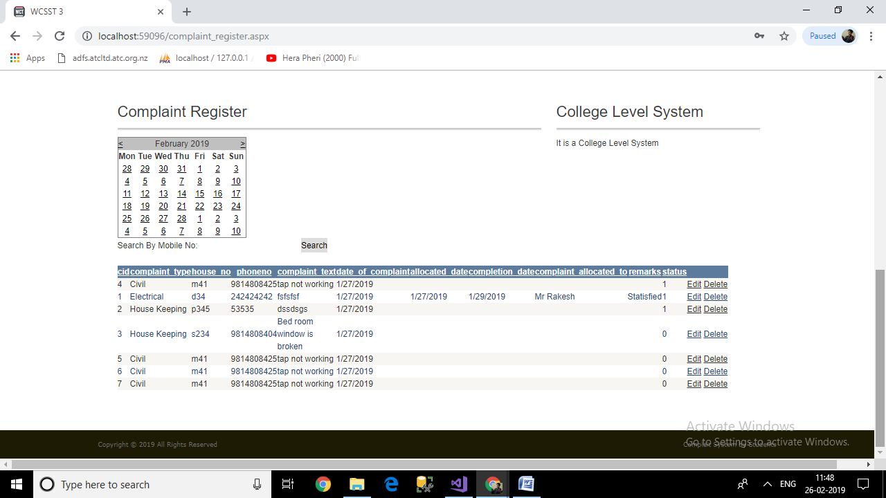

In this admin panel admin can allocate the person and also fill the expected date of addressal of the problem. Also can give remarks for the complaint that have been addressed.

**Product quality – what you delivered and what you expected to deliver, and the reasons for any variation.**

From the start we have think of such interface where students problems can be addressed. Student major issue is to have civil activities in the hostel. So that more easily people can approach the authority.

**How it measured against objectives and measures of success**

At the start major objective was to develop a interface where there are two types of people.

1. At client as student will be provided with easy interface.
2. Admin who will be allocating the task to the respective person.

**An evaluation of how well you thought the project went – what were the major successes, weaknesses and lessons learned.**

From the project there are various learning. There are easy ways by which various general purpose problems can be addressed using we platform. It is easy to access platform where person can easily access the services with secured solutions.

**Future scope**

In future various other works like enhancing the process to new area. Where students are facing problems. Currently we have space for the advertisement. In future some money earning ways can be identified through which small chunk of money can be earned to finance the web site.